### You need to install Circuitikz

<http://circuitikz.github.io/circuitikz/>

the instruction on the website can be confusing.

I use MikTex and search ‘Circuitikz’ and install it from there.

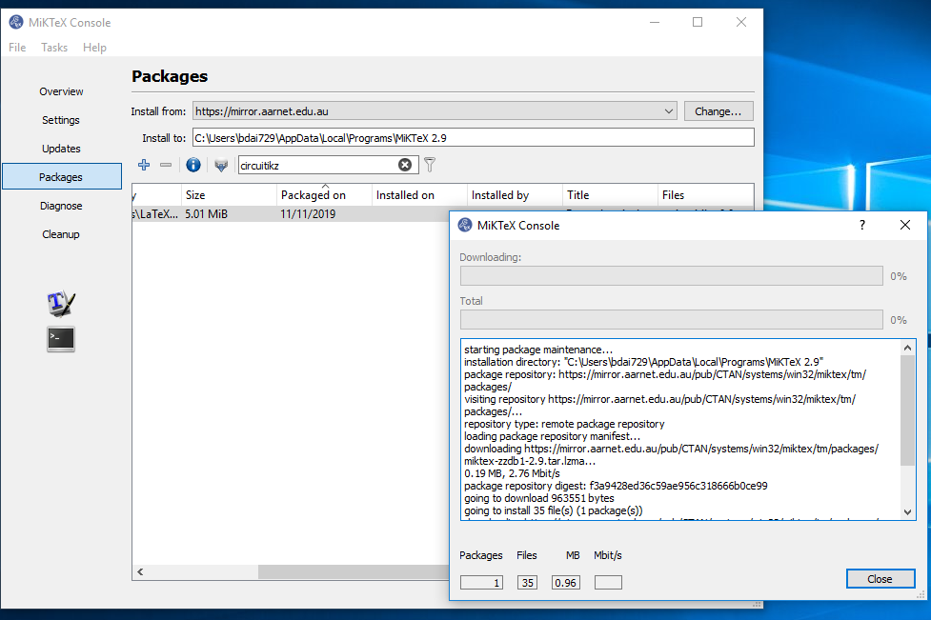

Without this, you will receive an error message as below

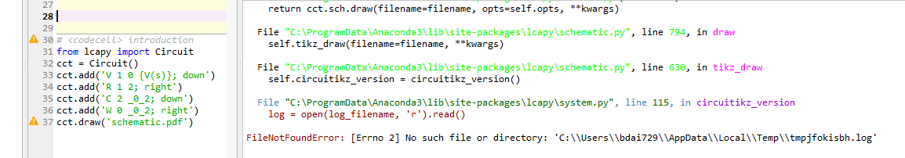

# <codecell> introduction

# this program does not work yet, I suspect this is because I have not

# successfully installed circuitikz package

from lcapy import Circuit

cct = Circuit()

cct.add('V 1 0 {V(s)}; down')

cct.add('R 1 2; right')

cct.add('C 2 _0_2; down')

cct.add('W 0 _0_2; right')

cct.draw('schematic.pdf')